Excel Project
Project Description
This project involves developing an Excel-based system to manage, analyze, and organize data for IMS College. The system maintains student records, course details, faculty information, event schedules, and departmental data. Using Excel features such as formulas, pivot tables, charts, and conditional formatting, the project provides insights into student performance, course enrollments, and faculty assignments. The solution enables the college administration to improve data accuracy, reporting efficiency, and decision-making, while keeping records structured, accessible, and easy to manage. Preferred Modules: Student Records, Course Details, Faculty Information, Event Scheduling, Departmental Data, Performance Analysis

Student Dashboard
- Visuals:
  - Line Chart → State by Student
  - Bar Chart → Course by Student
  - Donut Chart → Gender by student
  - Pie Chart → Year by Student
  - Cards → Total Student, Male, Female, Others
Faculty Dashboard
- Visuals:
  - Bar Chart → Qualification by Faculty
  - Donut Chart → Gender by Faculty
  - Line Chart → State by Faculty
  - Cards → Total Faculty, Male , Female , Others
Department & Course Dashboard
- Visuals:
  - Funnel Chart → Avg. Faculty Experience by Department
  - Bar Chart → Department by Total student
  - Bar Chart → Course by Total student
  - Line Chart → Department by Result
  - Cards → Total Department, total course

Event Dashboard
- Visuals:
  - Bar Chart → Total events
  - Bar Chart → total budget by Academic Year
  - Bar Chart → Events participants outcomes
  - Pie Chart → Total event by Organizer
  - Cards → Total events, Total budget

KPI SUMMARY
- Total Students = COUNTA('Students Master'!A2:A501)
- Total Faculty = COUNTA('Faculty Master'!A2:A21)
- Pass Count = COUNTIF('Semester Results'!I2:I2501,"Pass")
- Fail Count = COUNTIF('Semester Results'!I2:I2501,"Fail")
- Total Events = COUNTA('Events Master'!A2:A41)
- Total Participants = COUNTA('Event Participants'!A2:A2832)
- Average Marks = AVERAGE('Semester Results'!E2:E2501)
- Average Faculty Experience = AVERAGE('Faculty Master'!J2:J21)

Dashboard Screenshot
Student Dashboard
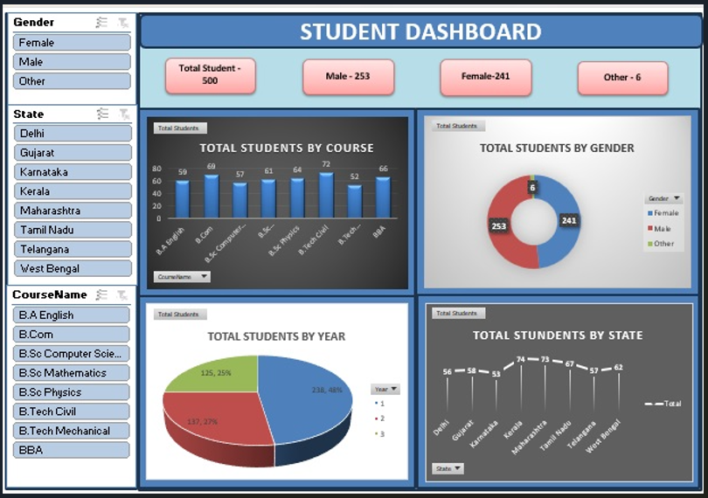

Faculty Dashboard
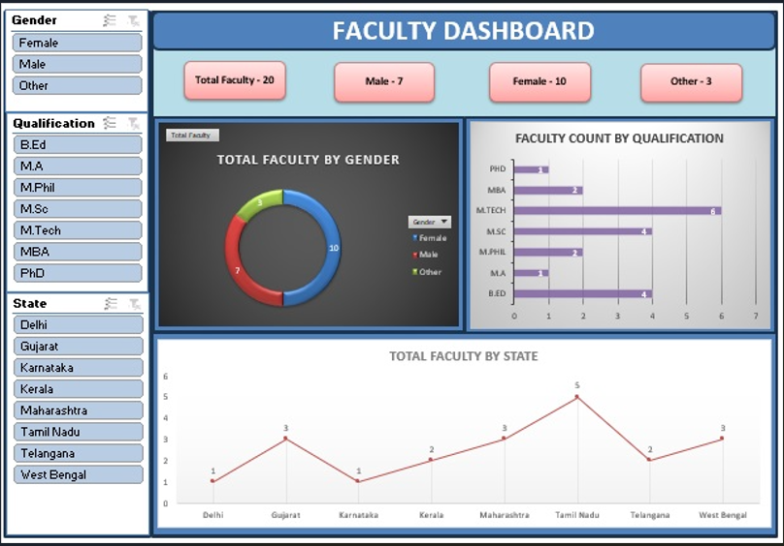
Department & Course Dashboard
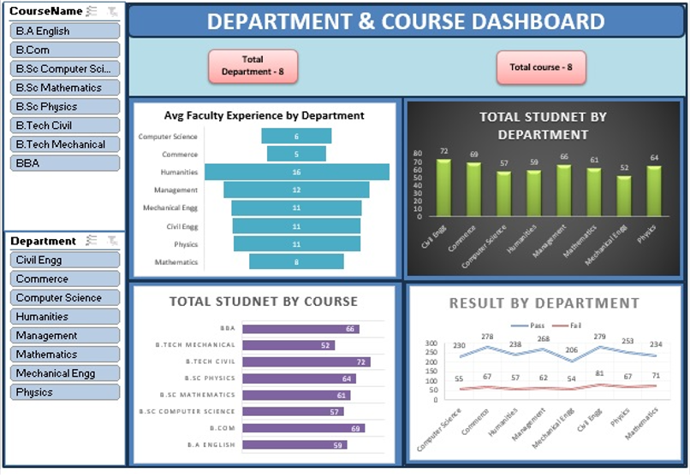
Events Dashboard
